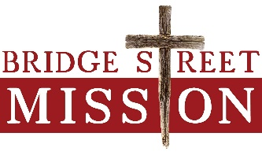

God’s Provision for the Least of These
Within the past six weeks or so, we have looked at a number of the laws God gave to His people Israel, in an effort to develop a personal Biblical or godly worldview. While these laws are not practiced today, nor are they a part of our federal and/or state laws, they give us a clue of how God operates and of what He is mindful. The following three were some I found quite interesting, and they reveal God’s heart.
“When you are harvesting your field and you overlook a sheaf, do not go back to get it. Leave it for the foreigner, the fatherless and the widow, so that the Lord your God may bless you in all the work of your hands. When you beat the olives from your trees, do not go over the branches a second time. Leave what remains for the foreigner, the fatherless and the widow. When you harvest the grapes in your vineyard, do not go over the vines again. Leave what remains for the foreigner, the fatherless and the widow.” Deuteronomy 24:19-22
We know that Deuteronomy is a second recounting of the Law by Moses to Israel, because an entire generation had died in the desert, and had not bothered to pass on the Law to their children and descendants. In a way, Moses was repeating what was given the first time by the Lord:
“When you reap the harvest of your land, do not reap to the very edges of your field or gather the gleanings of your harvest. Do not go over your vineyard a second time or pick up the grapes that have fallen. Leave them for the poor and the foreigner. I am the Lord your God.” Leviticus 19:9,10
He is a compassionate God! This was God’s Foodshare program—His “Second Harvest”—written right into the Law. And like any other word He gives, He means it! I am quite confident that the blessing He would give would far outweigh any benefit that could be gained from the sheaves, or the olives or the grapes that were gathered in going back over the property!
Our prayer is that God would bless each of you who have donated time, food, funds, that you could have used up completely for yourself and your family. We are so blessed to have these available to us for investing into the lives of the men in our Sober Living facility, as well as the approximately 100 homeless and poor that we are feeding daily down at our Outreach Center. If you could see the amount of meals that are served and handed out daily, you would be amazed. I, like the disciples, could easily ask, as I look at the very full dining room, “Where are we to get enough food to feed so great a crowd?” But thanks to the gospel accounts, I know Who to trust. And, has He delivered!!
Thank you for being part of God’s daily miracle work at Bridge Street Mission. He continues to bless us with what He has asked you to leave behind for us, and we know He will bless you for doing so.
In His Service—by His grace for His glory,
Todd Van Ryn
Executive Director

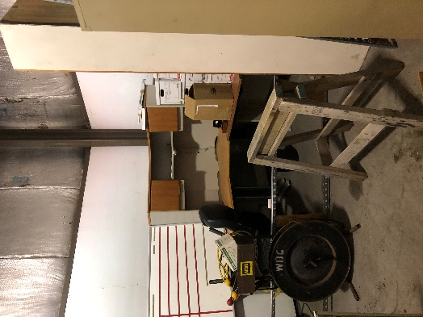
LOOKING FOR CONSTRUCTION HELP

Not sure what you are looking at in this picture?
This corner desk needs walls and a door around it!
We are continuing to work at our Donation Center to get it up and running as soon as possible.
Two Donation Center construction projects that still need to be completed:
1. Build a secure office space.
2. Build dressing rooms.
***Contact office for more information: 715-409-3506

Our Golf Outing is coming up fast. All funds from this fundraiser go directly back to Bridge Street Mission.
We are looking for golfers/teams and items for our silent auction.

$50 per person/ $200 per team includes lunch, golf cart, and 9 holes! Please contact Jeff Marg for golf registration/questions: jeffsellswausau@yahoo.com Please contact Denyon Homes or Bridge Street Mission Office for silent auction donations: Denyon Homes: 715-574-6005 Bridge Street Mission: 715-409-3506

How can I support Bridge Street Mission?
Pray for the Mission
Donate financially
Donate items for use at our resident building, or to our upcoming Donation Center
Sponsor a meal for weekly or monthly event
Volunteer to serve at an event or for the weekly lunch program
Volunteer to help set up Donation Center
Sponsor a movie night ($200)

DATE:
Thursday, September 10
TIME:
11:30am
LOCATION:
Crane Meadows Golf Course
8103 Weston Avenue

Bridge Street Mission’s
6th Annual Golf Outing at Crane Meadows

